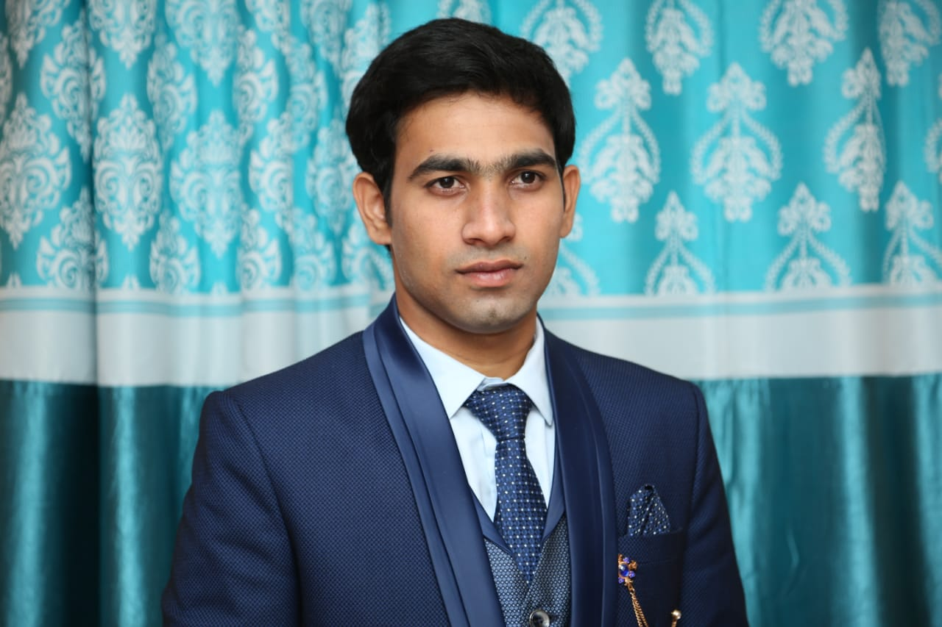Shabbir Shaikh

A-115 Dargha Building Makrabra Road Kala Talav Kalayn (West) 421301 DOB: 16th-Nov-1993

Mob: +91-9553919548

Email: [skshabbir6464@outlook.com](mailto:skshabbir6464@outlook.com) git: https://github.com/shabbirshaikh

# ABOUT ME

I'm having total +6.5 years of experience in IT delivery solutions and proficiency in working on Private and Public Cloud platforms. I love to dig into customer problems and solve them with modern technology. I focus on key results, build my amazing teams and quickly adapt to new insights. I am highly motivated to continue learning and improving my craft.

# WORK HISTORY

**Senior Consultant Team Lead Client – AxisBank**

Handling Team more then 50 members reporting management handling ticketing tool

Achieve 90% compliance level from 65%

Created Bash, Shell Scripting To Streamline Project Task

**-- Jan-2020 *till Present***

# SKILLS, PROFICIENCIES & TOOLS USED

Hands on experience on Public & Private Cloud Platforms such as AWS, VMware and Hyper-V etc.

SCM tools like Git, Gitlab,

Hands on experience on SCCM Patching application deployment server provisioning

CI/CD tools like Jenkins, AWS cloud native DevOps tools and GitHub Actions etc

Hands on experience on Automate the VA closer point is done through Qualys guard tool, common VA point associated were close by SCCM created bye services and registry packages IAC tool such as Terraform for maintaining the state of the infrastructure using S3 storage with DynamoDB table or Terraform Cloud as a backend. Containerization tool such as Docker for building images using Docker-file and Docker-compose etc.

Container Orchestration tool like Kubernetes for on premise environment and also with ECS and EKS Hands on experience on building VMware *V sphere* environment for on-premise infrastructure.

Installation, Configuration, Monitoring and Management of VMware V sphere 6/7 Hardware Installation such as Chassis and Blade Servers, Rack servers along with OS Through SCCM

# EDUCATIONAL BACKGROUND

Graduation TY-B com 2016-2017

LDS College, Maharashtra State

Higher Secondary Certificate (XII) - 2013-2014 LDS College, Maharashtra State

Secondary School Certificate (X) – 2010-201

NUH School

# Additional Qualification

MCSA Course Completed from NIIT CCNA Course Completed from CMS

Devops Master Course Completed from edureka Globally Certified in Virtualization Hyper-V

# HOBBIES & INTEREST

Learning new technologies in IT. Good Sleep :)

Loves to explore new places and restaurants.

**Preference Job location**

Mumbai Hyderabad Bangalore Chennai

Created automated CI/CD pipelines for testing, releasing and deploying applications using GitHub Actions, Jenkins and CodePipeline integrated with SCM tools for version control and issue tracking aspects of software development.

Created Terraform Modules based on application requirements and deployed resources on AWS cloud platform using IAC tool such as Terraform with S3 or Terraform Cloud as a backend for maintaining and tracking the state of the infrastructure.

Created Terraform Modules based on application requirements and deployed resources on AWS cloud platform using IaaC tool such as Terraform with S3 or Terraform Cloud as a backend for maintaining and tracking the state of the infrastructure.

Completed Kubernetes installation for on-premise VMs, ECS using EC2/ Fargate and EKS using EC2/Fargate etc. Also, deployed mini kube for testing.

Created Hardening Policy To Handling Server And Application Vulnerabilities in Qualys guard tool

Handling SCCM & V sphere for server Provisioning

Automate the VA closer point is done through Qualys guard tool, common VA point associated were close by SCCM-ansbile created bye services and registry packages

Built scalable and resilient applications using target groups, auto-scaling, LB with Cloud-watch alarm by creating specific AMI as launch configuration.

Successfully Upgraded SSCM console current brach up-gradation the existing axis bank SSCM infra from 2010 to current branch

Installation, configuration and management of VMware Infrastructure. Application Deployment Through SCCM, Ansible

**Senior Consultant | Client – Sutherland**

***-- May 2019 to Dec 2020***

Created scripts to run Pstool to Server integration Handling V sphere and SCCM to Server Provisioning

Automated the parts of software development related to building, testing, and deploying, facilitating continuous integration and continuous delivery.

Manage the virtualization infra such as VMware/Hyper-V Installing O365 troubleshooting and maintaining

Installation MaAcee Agent to handling Encryption-decryption

Handling SCCM for windows Server patching application Deployment& Handling BigFix Linux server

**Windows Admin Client – Kraheja Corporation**

## -- Aug 2017 to Jnu 2019

Installed and configured Windows Server 2012/2016 and Desktop Handing SCCM for desktop patching

Knowledge of Group policy OU,AD

Manged user creation and assign right to users Manged more then 7 Side from HO

Managed the virtualization infra such as VMware/Hyper-V, hardware component such as storages, physical servers & switches and daily backups

# Technical Skills & Expertise Tools

|  |  |
| --- | --- |
| Operation System | Windows server 2022,RHEL,Oracle,Mac |
| Version Control Tools | Git, Git Lab |
| Monitoring Tools | Prometheus, Grafana |
| Configuration Management Tools | SCCM, Ansbile |
| Provisioning Tools | SCCM,V sphere, Terrafrom |
| Integration Tools | BigFix, Jenkins |
| Containerization Tools | Docker, Kubernetes |
| Scripting Languages | Bash, Shell Scripting |
| Security Monitoring Tool | Qualys Cloud |
| Cloud Platform | AWS, GCP |
| IDE | Basic knowledge Visual Studio, Eclipse |